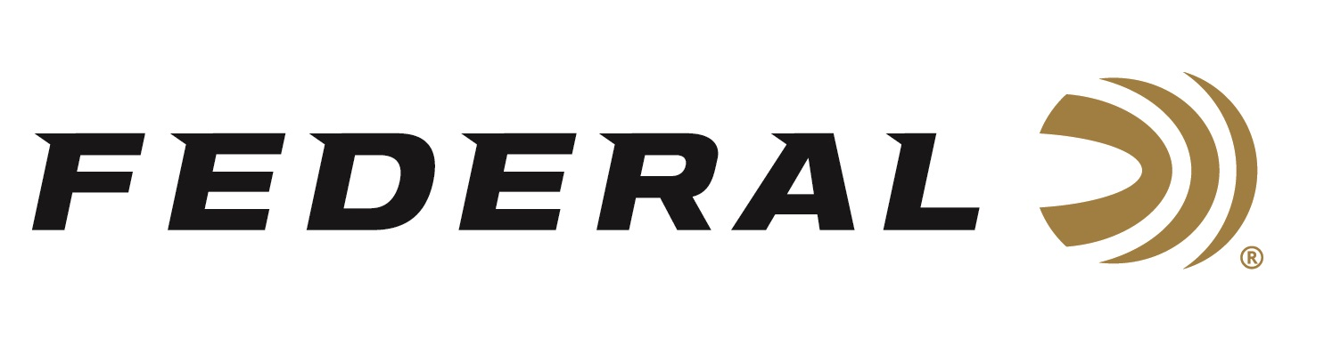

FOR IMMEDIATE RELEASE

Gone Fishin’ on the “It’s Federal Season” Podcast

ANOKA, Minnesota – September 23, 2021 – Today’s podcast topic takes listeners to the underwater world of catfish noodling. It is a phenomenon that Mike Rowe from the famed TV series “Dirty Jobs” profiled as his show was about to make history, and it is far from the ordinary. On this episode of “It’s Federal Season” podcast, the tiny but mighty Hannah Barron and her father Jeff join the discussion to talk about the sport and lifestyle that has brought them fame. The Alabama combination talk openly about their tactics and the dangers involved in submerging in mirky waters hunting for giant catfish.

Episode #26 “Gone Fishin’”
https://www.federalpremium.com/this-is-federal/podcast/

“Hannah and Jeff Barron are unique guests on a podcast dedicated to hunting and shooting,” stated Jason Nash, Federal Ammunition’s Vice President of Marketing. “They are a fun duo who are dedicated to the outdoors and tell a great story of the sport, the dangers they face, and their passion for hunting and shooting, as well as catfish noodling,” stated Nash.

In the news and notes segment, Federal will recap the exciting medal performances from our sponsored shooters at the Olympic Games in Tokyo.

For this episode, besides listening on the Federal Premium website or Talk North podcast network, you can also subscribe to Federal Ammunition’s YouTube channel (https://www.youtube.com/user/federalpremiumammo) and tune in for the discussion.

Federal Ammunition can be found at dealers nationwide or purchased online direct from Federal. For more information on all products from Federal or to shop online, visit www.federalpremium.com.

Press Release Contact: JJ Reich
Senior Manager – Press Relations
E-mail: VistaPressroom@VistaOutdoor.com

About Federal Ammunition
Federal, headquartered in Anoka, MN, is a brand of Vista Outdoor Inc., an outdoor sports and recreation company. From humble beginnings nestled among the lakes and woods of Minnesota, Federal Ammunition has evolved into one of the world's largest producers of sporting ammunition. Beginning in 1922, founding president, Charles L. Horn, paved the way for our success. Today, Federal carries on Horn's vision for quality products and service with the next generation of outdoorsmen and women. We maintain our position as experts in the science of ammunition production. Every day we manufacture products to enhance our customers' shooting experience while partnering with the conservation organizations that protect and support our outdoor heritage. We offer thousands of options in our Federal Premium and Federal® lines-it's what makes us the most complete ammunition company in the business and provides our customers with a choice no matter their pursuit.

